Assignment #3

# Basic Info:

This assignment is graded, and it worth 25 pts (out of 500 pts in total). The deadline is 11/12/23 11:59 PM.

If the Syllabus and/or class notification made by instructor or TAs indicates a different deadline, please refer to the latest information.

# Repository setup:

This section is previously used for the instruction for GitHub repo setting up. Since we're using the Bruin Learn platform now, you don't need to do the setup. Feel free to continue with the next step.

Of course, you should unzip the assignment material to your local file system (please unzip if you're reading this line inside the compression file preview now) and you can optionally use git to control your version.

You can continue with an IDE or using Chrome DevTools and we strongly recommend using of an IDE (For instruction about how to use an IDE, please refer to TA sections).

If you want to debug with Chrome DevTools, you can now follow the remaining steps of the assignment. This [debugger instruction](https://docs.google.com/document/d/e/2PACX-1vSi14Mb-_6qLN7wVA4-4NxqYR-3qHLy7ndjB2G0Ba6TCYHn_KGmrPbu-fCDtHkv9QcGBNqLUUdT6fu1/pub) can be helpful when your code does not work.

# Getting Started:

Please also check the examples in this [Demo-3 repo](https://github.com/Robert-Lu/tiny-graphics-demo3). It is highly recommended that you familiarize yourself with these code examples while attempting this assignment.

When you open your project, you will see a file that draws a single Torus shape

assignmetn3.js

(donut). Replace this scene with the solar system we specify in detail below.

Items in your code for you to fill in are marked TODO . You can also edit code outside of there.

Use our provided initial camera matrix that looks diagonally down at the scene, far back enough to see the entire scene.

Instantiate four spheres with each of 1, 2, 3, and 4 for the number of subdivisions. You may take advantage of previously given code for spheres.

For the sphere instances that have 1 or 2 subdivisions, use flat shading to build them. If you feel that you have to make edits in the code in places that are unspecified that is also fine but make sure to at least call the functions in the places that we state.

Flat Shading: In a flat shaded shape, all three corner points of a triangle have identical normal vectors, with all three vectors being exactly perpendicular to the triangle's planar face. Flat shading means more than just setting normal vectors, though; it also requires us to use a more restricted way of connecting vertices into triangles. We need to produce sharp, clearly defined edges on shapes. To do that, the process of flat shading a shape must ensure that the vertices along a sharp edge *do not get shared* by the triangles on either side of the edge. When triangles share references to a vertex, it saves storage space, but it also forces both triangles to use the same data at that point; not just position, but also normal vector, texture coordinate, etc. When we want an abrupt transition across an edge, though, we'd like the single edge to have different normal vectors depending on which triangle we're approaching the edge from. To get the flat shading effect, we cannot make our triangles share references to the same vertex, but instead must have duplicate vertices where sharp edges are. The duplicate vertices overlap in position, but with different normal vectors. That completes the effect. To flat shade an entire shape, all vertices must be unique, and no triangles can share any vertices. Exceptions can be made where faces are co-planar but that never happens in our spheres.

If you don't want to re-invent the sphere algorithm to make a flat-shaded version, you may use

the function built into our Shapes . To call it on a shape with class

make_flat_shaded_version()

name N, wherever N appears simply replace it with the code



(

N.prototype.make_flat_shaded_version() ) , including the outer parenthesis.

Materials: Recall that all Material objects really come from calling class

Material(shader,

options) . For this project we'll use the provided Phong_Shader and create two new

shaders and Ring_Shader . What are materials, besides objects that hold

Gouraud_Shader

a color? Well, they also store more settings for Phong shading, including numbers found in the Phong Reflection Model like the ambient coefficient, diffuse coefficient, specular coefficient, and shininess exponent. You can pass all of these values in inside a JavaScript object placed after the Color parameter when you construct a Material , mimicking how

our example instances do it. You can assign values to ambient, diffuse, and

Material

specular (leave shininess as the default). These coefficients range between 0 and 1.

Draw the following scene in the function of Assignment3 .

display()



(this is a GIF)

# Graded Steps

## Up to 25 points of credit. There is no partial credit on any individual requirement.

Implement the assignment in clean and understandable code. Each required part must successfully draw and show up onscreen in order to count.

If any parts are unclear, ask on Canvas.

## Point distribution

1. Place a spherical sun at the origin. Use a sphere that is subdivided 4 times. Use maximum ambient in the material. It swells from radius **1 up to 3** and then shrink from **3** **to 1** over an **10 second** period; and fades from red when it's smallest to white when it's biggest. - 2 points.
2. Make a point light source of the same color of the sun located in the center of the sun, with

10**n

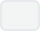

**

a size parameter equal to

where n is the current sun radius. In JavaScript,

is the

exponent operator. Since the light's size is changing and not the brightness, you should see the outer planets darken more than the inner ones whenever the sun shrinks. - 2 points.

1. Place four orbiting planets. Their radius shall all be 1. The smallest orbit shall be 5 units away from the sun and each orbit after shall be 3 units farther, with each farther planet revolving at a slightly slower rate than the previous. Leave the ambient lighting of each planet the default value of zero. - 3 points.
2. Planet descriptions, from the innermost to the outermost:

Planet 1: Gray, 2 subdivisions, flat shaded, diffuse only. - 2 points.

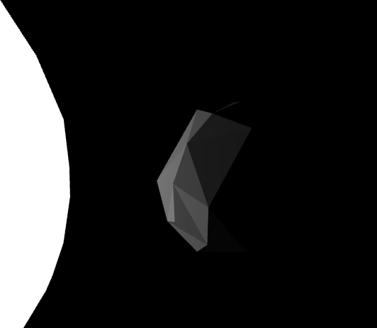

Planet 2: Swampy green-blue (suggest color #80FFFF ), 3 subdivisions, maximum specular, low diffuse. Apply Gouraud shading to it every odd second, but Phong shading every even second. - 4 points.

To Gouraud shade: Edit the class and create the Gouraud Shader

Gouraud_Shader

from the current Phong Shader template. Find the code that calculates the Phong formula. It's in a GLSL function called phong_model_lights() . Observe how either the vertex shader or fragment shader programs have the ability to call

to compute the Phong color. To perform Gouraud shading, make sure the color calculation occurs in the vertex shader. Otherwise, to perform

phong_model_lights()

phong_model_lights()

Phong shading, this process waits to call until the fragment

shader. Remember that with Gouraud shading, the fragment shader interpolates colors; with phong shading, the fragment shader interpolates normals.

 (this is a GIF)

Planet 3: Muddy brown-orange (suggest color #B08040 ), 4 subdivisions, maximum diffuse and specular. The planet could (*optionally*) wobble on in its rotation over time (have an axis not the same as the orbit axis). The planet must have a ring. You can use the provided torus shape, scaled flatter (reduced z axis scale). The ring and planet must wobble together - so base the ring's matrix directly on the planet's matrix. Give the ring the same color as the planet and set the material ambient only (for now). - 2 points.

Since the behavior wobble is kind of confusing, we decided to make it optional. It is acceptable to make the Planet 3 has a simple self-rotation (have an axis the same as the orbit axis) or just keep it still (no additional transformation) with respect to the sphere.

The 2 points here is for setting the correct material for the sphere of Planet 3, and the correct transformation. The material of the ring is not considered, since we will use a special shader to render it in the next requirement.

 (this is a GIF)

The

Next, give your planet 3's ring a custom shader, drawing repeated faded bands on it like Saturn. All you have to do is make sure it calculates color brightness in a way that varies sinusoidally with distance from the planet's center. - 4 points.

class already partially implements such a custom shader. It works with any

Ring_Shader

that has a field, and ignores all other fields. Draw with this shader by using

Shape

position

one of its materials (it generates blank ones, which is ok). When used, it already passes in for the GPU to use the following values: The shape positions, the model transform matrix, and the product of the projection and camera matrices. These values are available in the shader's GLSL code.

Your task is to use those available variables to fill in the GLSL shader code (the JavaScript

template strings returned by Specifically, the

void main()

and fragment_glsl_code() ).

is blank for both the vertex and fragment shader programs; fill

vertex_glsl_code()

these in to cause the GPU to store within the special GPU address called the

gl_Position

correct final resting place of the vertex, and store into the correct final color.

gl_FragColor

For testing, you can try storing simple placeholder values into those special variables -- such

vec3

vec4

vec4(

as the original model space position value, converted from a

to a

like this:

object_space_pos, 1) .

To color the ring use the color of planet 3, multiplied by some sinusoidal scalar function of your distance calculation, so that the color fades over distance from the center. Use the GLSL

function to compute distance. Both position and center are variables that you should calculate and store within the vertex shader; because we declared them as varying, they will be passed on to the fragment shader and available there.

distance()

The ring color need not be affected by lights (the sun's size), since it is using a simple shader that is not aware of lights.

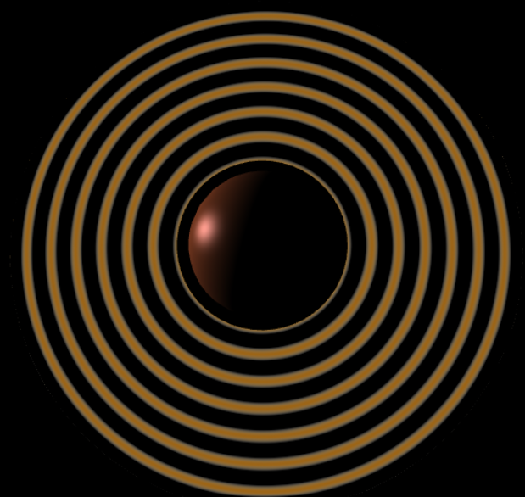

Planet 4: Soft light blue, 4 subdivisions, smooth phong, high specular. Add a moon for this planet. The moon has 1 subdivision, with flat shading, any material, and a small orbital distance around the planet. - 2 points.

 (this is a GIF)

1. Camera buttons: To help us grade, we have implemented some buttons. They are visible on your program, but they do not work at first. These buttons are intended to attach the camera to each planet, one at a time, fixed upon the front of the planet for closer viewing.

In order for these buttons to start working, your function must assign new values

display()

to your camera matrix. Your function must also fill in the following class-scope

display()

variables with the correct planet's model matrix: "this.planet_1" "this.planet_2"

"this.planet_3" "this.planet_4" "this.moon" .

Once you have those, the buttons will now set the function to return the

matrix of the planet we want. This is like storing a pointer to the planet's matrix that will always be up-to-date with new values of it. In JavaScript when we want a long-term pointer to a variable we often use a function returning a variable (a closure) instead.

this.attached()

Now you must call this.attached() to assign to the camera matrix. Only do the following when the value of this.attached is not undefined (so, when a button has already been pressed). Somewhere in display() , compute the desired camera matrix (let's call the matrix " desired ") by calling this.attached() , translating the returned value by 5 units to back away from the planet (we don't want to be inside of it), and then inverting that matrix (because it's going to be used for a camera, not a shape). Set the camera position as

with function program_state.set_camera(desired) or update

desired

to - 3 points.

program_state.camera_inverse

desired

1. This is a slight modification to what you'll do for the last sentence you just read in part 5. This will smooth out camera transitions more and give you slightly more control while attached.

Instead of directly assigning to program_state.camera_inverse , blend it with the

desired

existing camera matrix (from the previous frame) so that we smoothly pull the camera

towards equaling can use

desired.map((x,i) =>

instead of immediately getting there. To mix two matrices, you

where 0.1

desired

Vector.from(program_state.camera_inverse[i]).mix(x, blending_factor))

would make a good blending factor. - 1 points.



NOTE: At a blending speed of 0.1, you will still have some leeway to control the camera while attached (especially mouse steering), although it will tend to pull you back to viewing the selected planet. As you press the buttons, see if you can notice any undesired effects of blending matrices this way to generate intermediate camera matrices -- a subtle problem can be seen because our code snippet above uses linear blending instead of quaternions.

# Submitting Assignment 3:

Compress (zip) the whole assignment folder into a ZIP format compressed file. Submit it to the Assignment in Bruin Learn where you download this.

Please make sure you included everything in the assignment, rather than only the file(s) you made changes. The structure of the compressed file should be the same with the provided assignment material.